# The control commands summary of equipment in SinBerBEST BIMG Test-Bedding (continued 2)

2014.09.24

## Chapter 4: The control of AC Power Source

The AC power source emulator using in the SinBerBEST BIMG Test-Bedding is a MX series AC/DC Power Source, which now is coupled with 380 V three-phase AC Bus of the BIMG Test-Bedding. The MX series AC/DC Power System can be remotely controlled by a sub-set of commands in SCPI standard (Please see the attached MX series AC/DC Power Source programming manual for detail). To summarize the relevant control command in an easily understanding way, this chapter is in the style of example explanation on how to program the AC/DC source. Simple examples show you how to program:

* Output functions such as voltage, frequency, and phase
* The transient waveform generator
* Internal and external triggers
* Measurement functions
* User-defined waveforms
* The status and protection functions

## Power-on Initialization

When the AC source is first turned on, it wakes up with the output state defined by the PONSetup. In this state the output voltage is set to a value defined by the INIT:VOLT. The following commands are given implicitly at power-on:

*RST *CLS SRE 0 *ESE 0

*RST is a convenient way to program all parameters to a known state. Refer to Table 1-1 under the *RST command to see how each programmable parameter is set by *RST.

Table -1 *RST default parameter values

|  |  |  |  |
| --- | --- | --- | --- |
| **Item** | **Value** | **Item** | **Value** |
| INIT:CONT | OFF | [SOUR:]LIST:STEP | AUTO |
| OUT | OFF | [SOUR:]PHAS:MODE | FIX |
| OUTP:TTLT | OFF |  |  |
| OUTP:TTLT:SOUR | BOT |  |  |
| [SOUR:]CURR:PROT:DEL | 100ms | [SOUR:]VOLT:TRIG |  |
| [SOUR:]FREQ:MODE | FIX | [SOUR:]VOLT:SLEW:MODE | FIX |
| [SOUR:]FREQ:SLEW | MAX | [SOUR:]VOLT:SLEW:TRIG | MAX |
| [SOUR:]FREQ:SLEW:MODE | FIX | TRIG:CONN | NONE |
| [SOUR:]FREQ:SLEW:TRIG | MAX |  |  |
| [SOUR:]FREQ:TRIG | 60Hz | TRIG:SYNC:SOUR | IMM |
| [SOUR:]FUNC:MODE | FIX | TRIG:SYNC:PHAS | 0 |
| TRIG:SOUR | IMM |  |  |

## Enabling the Output

To enable the output, use the command:

OUTPut ON

## AC Voltage and Frequency

The AC rms output voltage is controlled with the VOLTage command. For example, to set the AC output voltage to 230 volts rms, use:

MODE AC; VOLTage 230

The AC/DC power source can be programmed to turn off its output if the actual output voltage does not agree within a given tolerance with the set value using the measurement query command.

Maximum Voltage: The maximum rms output voltage that can be programmed can be queried with:

VOLTage? MAX

The maximum voltage that the AC/DC source can output is limited by the maximum peak voltage capability of the AC/DC source. This value is expressed in the equivalent rms value of a sinewave (crest factor = 1.414). The maximum rms value is defined by the LIMIT subsystem. If a custom waveform is selected with a crest factor higher than 1.414, the maximum rms voltage will be less than the LIMIT value.

**Voltage Ranges:** The power source has two voltage ranges that are controlled by relays. The command that controls the range is:

VOLTage:RANGe MIN | MAX | 150 | 300 | 400

When the range is set to MIN (150), the maximum rms voltage that can be programmed for a sine wave is 150 volts rms, but it is only on this range that the maximum output current rating is available.

The VOLTage:RANGe command is coupled with the CURRent command. This means that the maximum current limit that can be programmed at a given time depends on the voltage range setting in which the unit is presently operating.

**Frequency:** The output frequency is controlled with the FREQuency command. To set the output frequency to 50 Hz, use:

FREQuency 50

## Voltage and Frequency Slew Rates

**Voltage Slew:** The AC source has the ability to control the slew rate of AC amplitude and frequency changes and DC amplitude. This can be used to generate ramps or to protect sensitive loads. To set the voltage slew rate to 20 volts per second, use:

VOLTage:SLEW 2 0

At *RST the slew rate is set to Maximum, which means that AC voltage changes occur at the fastest possible slew rate. The slew rate applies to programmed changes in AC/DC output amplitude while the unit is operating in fixed mode. Amplitude changes made by the step, pulse, and list transients are controlled by the same rules that apply to all other functions that are subject to transient control. See section 6.4.

**Frequency Slew:** The AC source also has the ability to control the slew rate of frequency changes. To set the frequency slew rate to 30 Hz per second, use:

FREQuency:SLEW 30

At *RST the slew rate is set to MAXimum, which means that frequency changes occur instantaneously. The frequency slew rate applies to programmed changes in frequency while the unit is operating in fixed mode. Frequency changes made by the step, pulse, and list transients are controlled by the same rules that apply to all other functions that are subject to transient control. See section 6.4.

## Programming the Output Phase

You can control the phase of the AC voltage waveform relative to an external reference with:

PHASe <n>

which sets the phase in degrees. If <n> is positive, the voltage waveform leads the internal reference or phase A value in three phase configuration.

***Note: For three phase clock and lock configurations, the PHASe command sets the relative phase of B and C with respect to phase A.***

## Current Limit

This command will set the rms current limit, to set this limit is:

CURRent <n>

where <n> is the rms current limit in amperes.

If the load attempts to draw more current than the programmed limit, and the source is set for constant current mode, the output voltage is reduced to keep the rms current within the limit. Since the rms detection involves a filter time constant that is long compared to a single output cycle, the response time of the rms current limit is not instantaneous.

The AC source can be programmed to turn off its output if the rms current limit is reached. This protection feature is activated when the source mode is set for constant voltage mode.

**Note:The CURRent command is coupled with the VOLTage:RANGe. This means that the maximum current limit that can be programmed at a given time depends on the voltage range setting in which the unit is presently operating. Refer to "Coupled Commands" for more information.**

## Waveform Shapes

At *RST, the AC/DC power source generates a sine waveform when in AC or AC+DC mode, but other shapes can be selected. There are built-in tables for sine, square and clipped sine waveforms. In addition, the user can define arbitrary waveshapes by creating a 1024 point table of amplitudes for a single cycle.

As shown in the following examples, the FUNCtion[:SHAPe] command selects the output waveform.

**Clipped Waveform:** To select a clipped sine waveform use:

FUNCtion:SHAPe CSINe

To set the clipping level to 10% THD, use:

FUNCtion:SHAPe:CSINe 10

The clipping level is specified in terms of the percent total harmonic distortion in the clipped sine waveform.

**User-Defined Waveform:** To create a user-defined waveform, use TRACe:DEFine command to create a name for the waveform, then use the TRACe[:DATA] command to send the list of 1024 amplitude points. The waveform can then be selected using the FUNCtion command. For example, a waveform named "Distortion" can be created with:

TRACe:DEFine DISTORTION

TRACe:DATA DISTORTION, n1, n2, n3, ..., n1024

where n1 ... n1024 are the data points that define the relative amplitudes of exactly one cycle of the waveform. The first data point defines the amplitude that will be output at 0 degrees phase reference.

Data points can be in any arbitrary units. The AC source scales the data to an internal format that ensures that the correct ac rms voltage is output when the waveform is selected. When queried, trace data is returned as normalized values in the range of ±1. Waveform data is stored in nonvolatile memory and is retained when input power is removed. Up to 50 user defined waveforms may be created and stored in one of 4 separate groups.

Because waveform shape commands are coupled with the voltage commands, changing waveforms without changing the programmed voltage may result in an error if the resulting peak voltage amplitude exceeds the maximum voltage rating of the AC/DC power source. Refer to "Coupled Commands" for more information.

## Individual Phases

On three phase models or configurations, the following functions can be controlled separately on each phase:

* VOLTage
* CURRent
* PHASe
* FUNCtion
* MEASure
* FETCh
* CALibrate

**Selecting a Phase:** Two commands determine which output phase or phases receive commands in the three phase mode. These are:

INSTrument:COUPle ALL|NONE INSTrument:NSELect <n>

The *RST setting for INSTrument:COUPle is NONE. This setting causes programming commands to be sent to the selected output phases only.

To send a programming command to all of the output phases, set INSTrument:COUPle to ALL. For individual phase programming use ALL, then select the desired output to receive the command with INSTrument:NSELect. For example, when the commands

INSTrument:COUPle NONE INSTrument:NSELect 2

are sent, all subsequent voltage commands will go to output phase 2, and all measurement queries will return readings from output phase 2.

**Note: The INSTrument:COUPle command has no effect on queries. In the** **three-phase mode, queries are always directed to the output selected by INSTrument:NSELect.**

**Programming the Output Phase:** You can control the phase of the ac voltage waveform relative to an internal reference or to phase A with:

PHASe <n>

which sets the phase in degrees. If <n> is positive, the voltage waveform leads the internal reference.

The INSTrument:COUPle setting is ignored by the PHASe command—it always controls the output selected by INSTrument:NSELect.

## Coupled Commands

This section describes how to avoid programming errors that may be caused by the error checking done for coupled commands such as VOLTage:LEVel.

Commands that are coupled to the VOLTage command are the output transient commands that control step, pulse and list generation. When an output transient is initiated (ready to receive a trigger), the error checking that takes place for maximum rms voltage.

CURRent:LEVel and VOLTage:RANGe

Programming the current limit by itself to a value that is greater than the maximum allowed on the presently programmed voltage range causes an error. If the commands

VOLTage:RANGe 300 CURRent 9 0

are sent, an error will be generated because the CURRent command is requesting a current limit that is outside the maximum value allowed on that voltage range.

Programming the VOLTage:RANGe by itself causes the programmed current limit to be set to the maximum for the given range if it had previously been higher than the maximum setting for the new range. If the commands

VOLTage:RANGe 150 CURRent 125 VOLTage:RANGe 300

are sent, no error will be generated because the second VOLTage:RANGe command automatically sets the programmed current limit to 62.5, which is the maximum value for the programmed voltage range.

Programming both the current and the voltage range in one program message unit can be done based on the order and the initial voltage setting. If the following commands are sent:

VOLTage:RANGe 300

CURRent 62.5;:VOLTage:RANGe 150;:CURRent 125

no error will be generated because the combined current limit and voltage range specified on the second line are within the output ratings of the power source, but the voltage range command must be sent before the current command.

## Programming Output Transients

Output transients are used to:

* Synchronize output changes with a particular phase of the voltage waveform.
* Synchronize output changes with internal or external trigger signals.
* Simulate surge, sag, and dropout conditions with precise control of duration and phase.
* Create complex, multi-level sequences of output changes.
* Create output changes that have rapid or precise timing requirements.

The following AC/DC source functions are subject to transient control:

* AC output voltage
* DC output voltage
* Frequency
* Start phase angle
* AC/DC voltage slew rate
* Frequency slew rate

The following transient modes can be generated:

|  |  |
| --- | --- |
| Step | generates a single triggered output change. |
| Pulse | generates an output change which returns to its original state after some time period. |
| List | generates a sequence of output changes, each with an associated dwell time or paced by triggers. |
| Fixed | turns off the transient functions, which means that only the IMMediate values are used as the data source for a particular function. After a *RST or  Device Clear command, all functions are set to FIXed, which turns off the transient functions. |

## Transient System Model

Figure 11-1 shows a model of the transient system. The figure shows the transient modes and the output waveform that is generated in each mode.

When a trigger is received in step or pulse modes, the triggered functions are set from their IMMediate to their TRIGgered value. In Step mode, the triggered value becomes the immediate value. In Pulse mode, the functions return to their immediate value during the low portion of the pulse.

If there are no further pulses, the immediate value remains in effect. In List mode, the functions remain at the last list value at the completion of the list.

You can not mix STEP, PULSe, and LIST modes among functions.

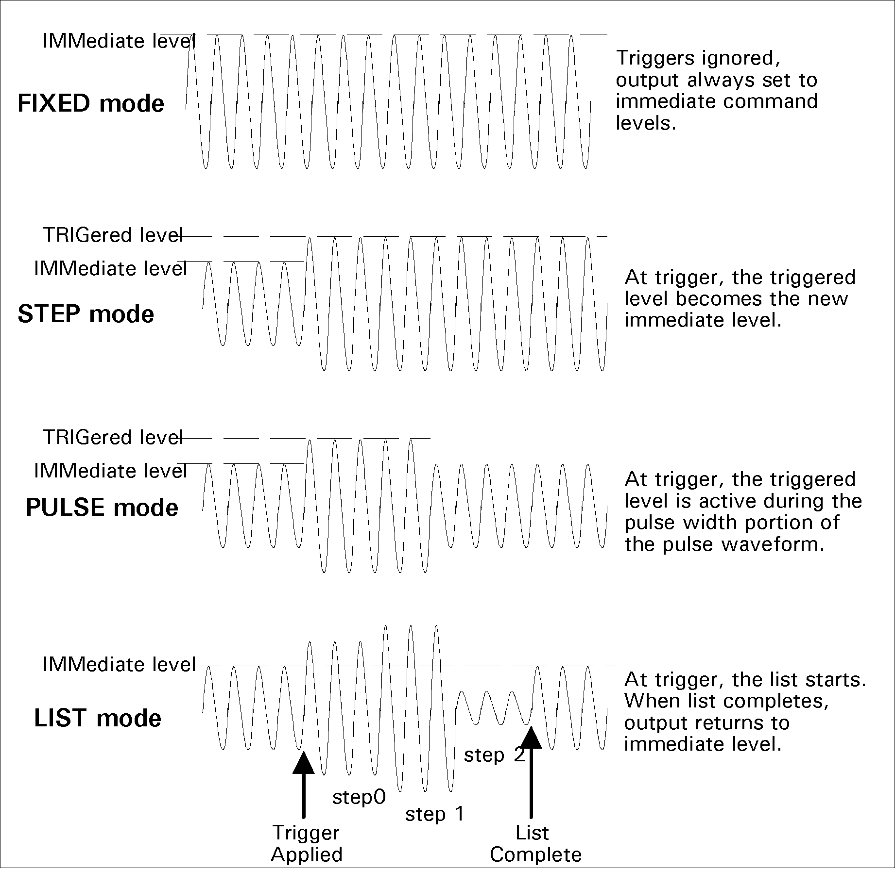

Figure 1-1 Output Transient System

## Step and Pulse Transients

Step 1: Set the functions that you do not want to generate transients to FIXed mode. A convenient way to do this is with the *RST command. Then set the mode of the function that will generate the transient to STEP or PULSe as required. For example, to enable the voltage function to generate a single triggered output voltage change, use:

*RST

VOLTage:MODE STEP

Step 2: Set the triggered level of the function that will generate the transient. For example, if the previously programmed voltage function is going to step the output voltage amplitude to 135 volts upon reciept of a trigger, use:

VOLTage:TRIGger 135

Step 3: Select the trigger source that will generate the trigger. For example, to select the Immediate use:

TRIGger:SOURce IMM

Trigger sources are discussed in detail under "Triggering Output Changes"

Step 4: Only perform this step if you have selected PULSE as the transient mode in Step 1. Specify the pulse count, the pulse period, and then either the duty cycle or the pulse width using the following commands:

|  |  |
| --- | --- |
| PULSe:COUNt 1 | specifies 1 output pulse |
| PULSe:PERiod 1 | specifies a pulse period of 1 second |
| PULSe:DCYCle 50 | specifies a duty cycle of 50% |
| PULSe:WIDTh .5 | seconds (not necessary in this case since a duty cycle has already been specified) |

Step 5: Initiate the transient trigger system to enable it to receive a trigger. To enable the trigger system for one transient event use:

INITiate

The following example programs a voltage dropout for 2 cycles of a 230 volt, 50 Hz output. The dropout begins at the positive peak of the output voltage waveform (90 degrees phase) and is triggered by IEEE-488 bus trigger:

|  |  |
| --- | --- |
| *RST | Begin at power-on state |
| VOLT 20 | Set initial output voltage (immediate-level) |
| FREQ 50 | Set initial output frequency |
| OUTP ON | Enable the output |
| VOLT:MODE PULS | Enable output to generate pulses when triggered |
| VOLT:TRIG 0 | Set the voltage dropout (triggered level) |
| PULS:WIDT 0.05 | Set pulse width for 2 periods |
| PULS:PER 0.1 | Set pulse period for 4 cycles |

|  |  |
| --- | --- |
| TRIG: SOUR BUS | Respond to IEEE-488 bus triggers |
| TRIG: SYNC:SOUR:PHAS | Synchronize triggers to internal phase reference |
| TRIG: SYNC:PHAS 90 | Sets internal phase reference point to 90 degrees |
| INIT | Set to Wait-for-trigger state |
| <device trigger> | Send the IEEE-488 bus trigger |

## List Transients

List mode lets you generate complex sequences of output changes with rapid, precise timing, which may be synchronized with internal or external signals. Each function that can participate in output transients can also have an associated list of values that specify its output at each list point.

You can program up to 32 settings (or points) in the list, the time interval (dwell) that each setting is maintained, the number of times each data point is repeated, the number of times that the list will be executed, and how the settings change in response to triggers.

All list point data can be stored in nonvolatile memory using one of the available setup register. This means that the programmed data for any list function will be retained when it is saved in the register when the AC source is turned off.

Note: If the transient list is programmed over the bus, the transient must be executed at least once or it will not be saved to the setup register when the *SAV command is sent. Unexecuted transient lists have not been compiled yet by the AC/DC power source controller and will not be saved as part of a front panel setup. This is not the case when the transient list is entered from the front panel. Front panel entered transient lists will be saved even if they have not been executed yet.

Lists are paced by a separate list of dwell times which define the duration of each output setting. Therefore, each of the up to 32 list points has an associated dwell time, which specifies the time (in seconds) that the output remain at that setting before moving on to the next setting.

The following procedure shows how to generate a simple list of voltage and frequency changes.

Step 1: Set the mode of each function that will participate in the output sequence to LIST. For example:

VOLTage:MODE LIST FREQuency:MODE LIST

Step 2: Program the list of output values for each function. The list commands take a comma-separated list of arguments. The order in which the arguments are given determines the sequence in which the values will be output. For example, to cycle the voltage through a sequence that includes nominal line, high line, and low line, a list may include the following values:

LIST:VOLTage 135, 100, 120, 135, 100, 128, 110, 102, 132, 112

You can specify lists for more than one function. For example, to synchronize the previous voltage list with another list that varies the output frequency from nominal, to high, to low, the lists may include the following values:

LIST:VOLTage 135, 100, 120, 135, 100, 128, 110, 102, 132, 112 LIST:FREQuency 60, 60, 60, 63, 63, 63, 57, 57, 57, 60

All lists must have the same number of data values or points, or an error will occur when the transient system that starts the sequence is later initiated. The exception is when a list has only one item or point. In this case the single-item list is treated as if it had the same number of points as the other lists, with all values being equal to the one item. For example:

LIST:VOLTage 120, 100, 110; FREQuency 60 is the same as:

LIST:VOLTage 120, 100, 110 LIST:FREQuency 60, 60, 60

Step 3: Determine the time interval that the output remains at each level or point in the list before it advances to the next point. The time is specified in seconds. For example, to specify five dwell intervals, use:

LIST:DWELl 1, 3.5, 1.5, 0.5, 3.8, 1.2

The number of dwell points must equal the number of output points. If a dwell list has only one value, that value will be applied to all points in the output list.

Step 4: Determine the number of times the list is executed before it completes. For example, to run a list 10 times use:

LIST:COUNt 10 At *RST, the count is set to 1.

Step 5: Determines how the list sequencing responds to triggers. For a closely controlled sequence of output levels, you can use a dwell-paced list. To cause the list to be paced by dwell time use:

LIST:STEP AUTO

As each dwell time elapses, the next point is immediately output. This is also the *RST setting.

If you need the output to closely follow asynchronous events, then a trigger-paced list is more appropriate. In a trigger-paced list, the list advances one point for each trigger received. To enable trigger-paced lists use:

LIST:STEP ONCE

The dwell time associated with each point determines the minimum time that the output remains at that point. If a trigger is received before the previous dwell time completes, the trigger is ignored. Therefore, to ensure that no triggers are lost, program the dwell time minimum.

Step 6: Use the transient trigger system to trigger the list. This is described in detail under "Triggering Output Changes"

## Triggering Output Changes

The following transient trigger sources can be selected:

|  |  |
| --- | --- |
| IMMediate | Generates a trigger when the trigger system is initiated. |
| BUS | Selects IEEE-488 bus triggers. |

## Trigger System Model

Figure 15-1 is a model of the trigger system. The rectangular boxes represent states. The arrows show the transitions between states. These are labeled with the input or event that causes the transition to occur.

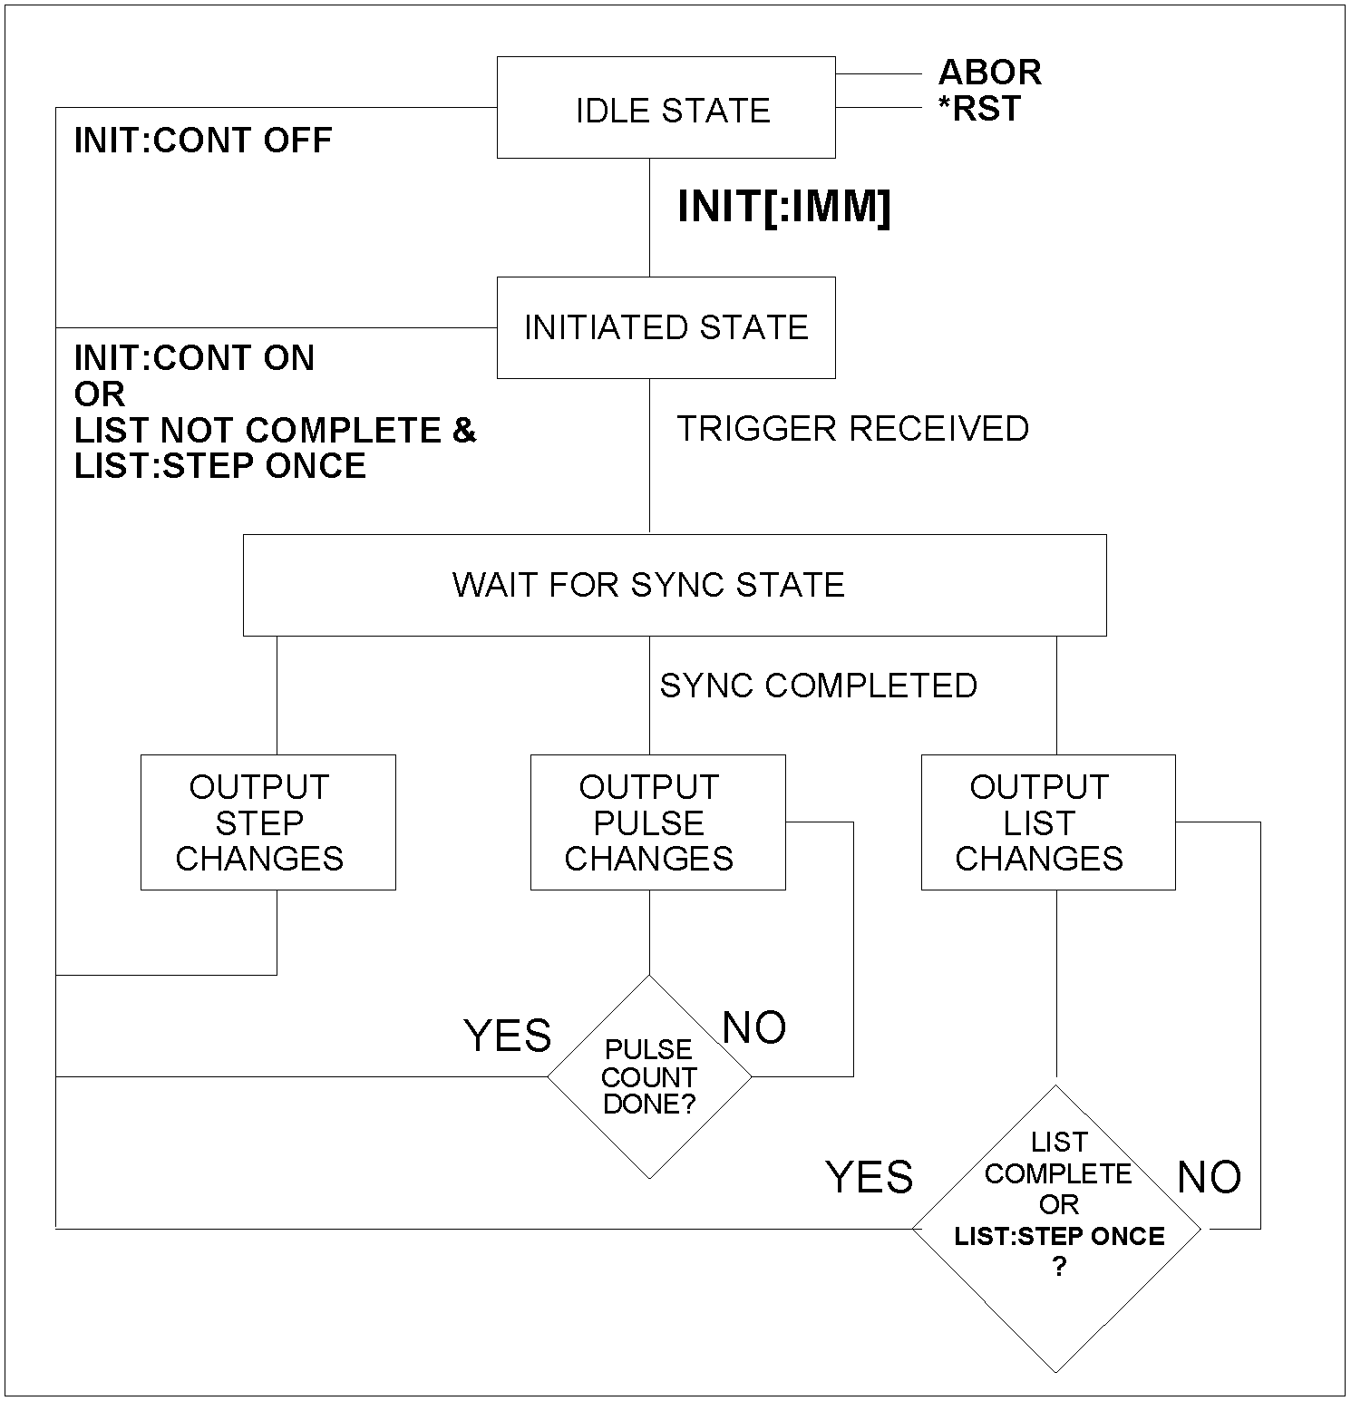

*Figure 15-1: Transient Trigger System Model*

## Initiating the Output Trigger System

Figure 11-1 shows a model of the transient system. The figure shows the transient modes and the output waveform that is generated in each mode.

When the source is turned on, the trigger subsystem is in the idle state. In this state, the trigger subsystem ignores all triggers. Sending the following commands at any time returns the trigger system to the Idle state:

ABORt *RST

The INITiate commands move the trigger system from the Idle state to the Initiated state. This enables the AC source to receive triggers. To initiate for a single triggered action, use:

INITiate:IMMediate

After a trigger is received and the action completes, the trigger system will return to the Idle state. Thus it will be necessary to initiate the system each time a triggered action is desired. To keep a trigger system initiated for multiple actions without having to send an initiate command for each trigger, use:

INITiate:CONTinuous ON

Selecting the Trigger Source

The trigger system is waiting for a trigger signal in the Initiated state. Before generating a trigger, a trigger source must be select.

To select IEEE-488 bus triggers (group execute trigger, device trigger, or *TRG command), use:

TRIGger:SOURce BUS

To select a trigger source that is always true, use:

TRIGger: SOURce IMM

The immediate source can be combined with INITiate:CONTinuous ON to generate repetitive output transients. A transition from the Initiated state to the Delay state is made when the trigger signal is received.

## Synchronizing Output Changes to a Reference Phase Angle

An output transient normally occurs immediately when the trigger signal is received. For some applications it is desirable for the transient to be synchronized with a particular phase of the output waveform such as the zero crossing point (0°) or the positive peak (90°).

To synchronize the start of a transient with a particular phase angle of the internal phase reference, you must select PHASE as the trigger source. Use:

TRIGger:SYNC:SOURce PHASe

To select the desired phase, use:

TRIGger:SYNC:PHASe 90

which specifies the 90 degree phase angle of the internal phase reference as the point where the transient begins.

To turn off transient phase synchronization, use:

TRIGger: SYNC:SOURce IMMediate

When IMMediate is selected, the trigger system goes directly to the Output state. This is the parameter selected at *RST.

## Generating Triggers

Providing that you have specified the appropriate trigger source, you can generate triggers as follows:

**Single Triggers, B**y sending one of the following over the IEEE-488:

* INIT
* *TRG
* a group execute trigger

**Continuous Triggers**, by sending the following commands over the IEEE-488:

* TRIGger: SOURce IMMediate
* INITiate:CONTinuous ON

When the trigger system enters the Output Change state upon receipt of a trigger (see Figure 6-5), the triggered functions are set to their programmed trigger levels. When the triggered actions are completed, the trigger system returns to the Idle state.

**Specifying a Dwell Time for Each List Point**

Each voltage and frequency list point has an associated dwell time specified by:

LIST:DWELl <n> ,<n>

where <n> specifies the dwell time in seconds. The number of dwell points must equal the number of output points. If a dwell list has only one value, that value will be applied to all points in the output list. After each new output level or point is programmed, the output remains at that point in the list for the programmed dwell interval before the list advances to the next point. Only an ABORt command can transfer the system out of the Dwelling state.

At the end of the dwell interval, the transition to the next state depends on whether or not the list has completed its sequencing and the state of the LIST:STEP command (see Figure 6-5).

If the list is completed, the trigger system returns to the Idle state. If the list is not completed, then the system reacts as follows:

LIST:STEP ONCE programs the trigger system to return to the Initiated state to wait for the next trigger.

LIST:STEP AUTO programs the trigger system to immediately execute the next list point.

## Acquiring Measurement Data

The source has the capability to return a number of current, voltage, and power measurements. When the AC source is turned on, it is continuously sampling the instantaneous output voltage and current for several output cycles and writing the results into a buffer. The buffer holds 4096 voltage and current data points.

The AC source uses the data from the voltage and current buffer to calculate the requested measurement information. Data in the voltage and current buffers is always re-acquired for subsequent measurement requests. There are two ways to make measurements:

* Use the MEASure commands to immediately start acquiring new voltage and current data, and return measurement calculations from this data as soon as the buffer is full. This is the easiest way to make measurements, since it requires no explicit trigger programming.
* Use an acquisition trigger to acquire the voltage and current data from the buffer. Then use the FETCh commands to return calculations from the data that was retrieved by the acquisition trigger. This method gives you the flexibility to synchronize the data acquisition with an external signal. FETCh commands do not trigger the acquisition of new measurement data, but they can be used to return many different calculations from the same set of data that was captured as a result of same acquisition trigger.

The query response for measurements is not immediate. The source will accept commands from the interface while the measurement in progress. To prevent the source from accepting additional commands during measurement the *WAI must be used with the measurement query command.

MEAS:FREQ?;*WAI

Making triggered measurements with the acquisition trigger system is discussed under "Triggering Measurements".

Note: For each MEASure form of the query, there is a corresponding query that begins with the header FETCh. FETCh queries perform the same calculation as their MEASure counterparts, but do not cause new data to be acquired. Data acquired by an explicit trigger or a previously programmed MEASure command are used.

## Voltage and Current Measurements

To the rms voltage or current, use:

MEASure:VOLTage? or MEASure:CURRent?

To measure the dc voltage or current, use:

MEASure:VOLTage:DC? or MEASure:CURRent:DC?

To measure the maximum current amplitude and the current crest factor, use:

MEASure:CURRent:AMPLitude:MAXimum? MEASure:CURRent:CREStfactor?

To reset the peak measuremnt , use

MEAS:CURR:AMPL:RESet

## Power Measurements

The MEASure queries can return real, and apparent power measurements as well as dc power and power factor using the following commands:

|  |  |
| --- | --- |
| MEASure:POWer:AC:APParent? | measures the AC component of apparent power in VA |
| MEASure:POWer:AC:REAL? | measures the in-phase component of power in watts |
| MEASure:POWer:AC:PFACtor? | returns the output power factor |
| MEASure:POWer:DC? | measures the dc component of power |

## Frequency Measurements

To measure the frequency, use the following command:

MEASure:FREQuency?

## Harmonic Measurements

The MEASure and FETCh queries can return the amplitude and phase of up to the 50th harmonic of voltage and current. They can also return the total harmonic distortion in the output voltage or current. For example, to return readings for an individual harmonic component, use the following commands:

MEASure:CURRent:HARMonic:AMPLitude? <harmonic number> MEASure:CURRent:HARMonic:PHASe? <harmonic number> MEASure:VOLTage:HARMonic:AMPLitude? <harmonic number> MEASure:VOLTage:HARMonic:PHASe? <harmonic number>

Harmonic numbers are related to the programmed frequency of output voltage. Queries sent with an argument of 0 return the dc component. An argument of 1 indicates the fundamental frequency, 2 indicates the second harmonic, 3 indicates the third, and so on.

The maximum harmonic component that can be read is limited by the fundamental measurement bandwidth, which is 19.53 kHz for a single phase configuration and 6.51kHz for three phase configuration. An error is generated if a query is sent for a harmonic that has a frequency greater than the bandwidth above. To return all the harmonic components with a single query, use the following commands:

MEASure:ARRay:CURRent:HARMonic:AMPLitude? [<n>] MEASure:ARRay:CURRent:HARMonic:PHASe? [<n>] MEASure:ARRay:VOLTage:HARMonic:AMPLitude? [<n>] MEASure:ARRay:VOLTage:HARMonic:PHASe? [<n>]

These queries always return 51 data values, from the dc component up to the the numeric option field <n> if present or the 50th harmonics. Any harmonics that represent frequencies greater than the measurements bandwidth are returned as the value 0. To return the percentage of total harmonic distortion in the output voltage or current, use the following commands:

MEASure:CURRent:HARMonic:THD?

MEASure:VOLTage:HARMonic:THD?

## Simultaneous Output Phase Measurements

Figure 6-1 shows a model of the transient system. The figure shows the transient modes and the output waveform that is generated in each mode.

You can return simultaneous measurements from all output phases of the source in the three phase mode using the FETCh query. Unlike MEASure queries, FETCh queries do not trigger the acquisition of new data when they are executed. First, you must initiate the measurement trigger system and generate a measurement trigger as explained in the following section "Triggering Measurements". When the measurement data has been acquired by the voltage and current data buffers for each output phase, use INSTrument:NSELect to select each phase, and FETCh to return the specified measurement data. The following commands return rms voltage:

INSTrument:NSELect 1

FETCh:VOLTage:AC?;*WAI

INSTrument:NSELect 2

FETCh:VOLTage:AC?;*WAI

INSTrument:NSELect 3

FETCh:VOLTage:AC?;*WAI

## Returning Voltage and Current Data From the Data Buffer

The MEASure and FETCh queries can also return all 4096 data values of the instantaneous voltage and current buffers. These are:

MEASure:ARRay:CURRent[:DC]?;*WAI

MEASure:ARRay:VOLTage[:DC]?;*WAI

## Triggering Measurements

You can use the data acquisition trigger system to synchronize the timing of the voltage and current data acquisition with an external trigger source. Then use the FETCh commands to return different calculations from the data acquired by the measurement trigger.

The following measurement trigger sources can be selected:

|  |  |
| --- | --- |
| IMMediate | Aquire the measurements immediate |
| SYNChronize | Internal to phase A angle |
| BUS | IEEE-488 device, *TRG, or <GET> (Group Execute Trigger) |
| TTLTrg | The signal driving the Trigger Out |

## Measurement Trigger System Model

Figure 6-3 is a model of the measurement trigger system. The rectangular boxes represent states. The arrows show the transitions between states. These are labeled with the input or event that causes the transition to occur.

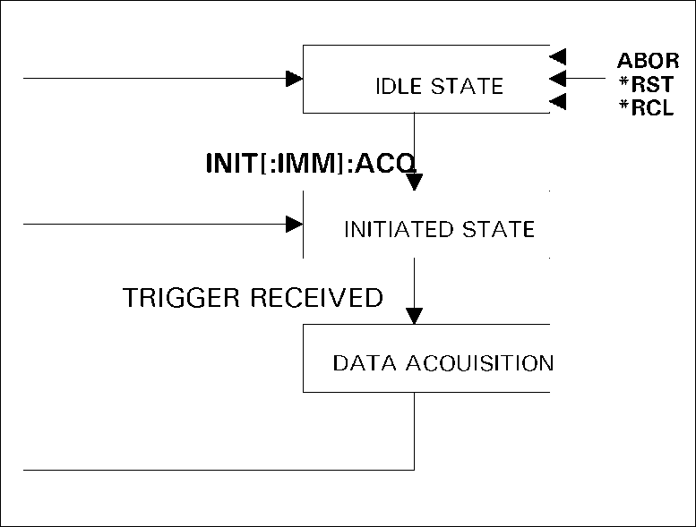

Figure 6-3: Measurement Acquisition Trigger Model

## Initiating the Measurement Trigger System

When the AC source is turned on, the trigger system is in the idle state. In this state, the trigger system ignores all triggers. Sending the following commands at any time returns the trigger system to the Idle state:

ABORt *RST *RCL

The INITiate commands move the trigger system from the Idle state to the Initiated state. This enables the AC source to receive triggers. To initiate for a measurement trigger, use:

INITiate:IMMediate:ACQuire

After a trigger is received and the data acquisition completes, the trigger system will return to the Idle state. Thus it will be necessary to initiate the system each time a triggered acquisition is desired.

***Note:You cannot initiate measurement triggers continuously. Otherwise, the*** ***measurement data in the data buffer would continuously be overwritten by each triggered measurement.***

## Selecting the Measurement Trigger Source

The trigger system is waiting for a trigger signal in the Initiated state. Before you generate a trigger, you must select a trigger source. To select the SYNC Trigger to start the measurement at specific phase angles in the waveform:

TRIGger:ACQuire:SOURce SYNC

TRIGger:SYNC:SOUR PHAS

TRIGger:SYNC:PHASE 0

To select IEEE-488 bus triggers (group execute trigger, device trigger, or *TRG command), use:

TRIGger:ACQuire:SOURce BUS

To select the signal driving the Trigger Out from the transient, use:

TRIGger:ACQuire:SOURce TTLTrg

## Generating Measurement Triggers

Providing that you have specified the appropriate trigger source, you can generate triggers as follows:

* By sending one of the following over the IEEE-488:
  + TRIGger:ACQuire:IMMediate
  + *TRG
  + a group execute trigger (GET)
* By waiting for a specific phase angle of the waveform
* By generating an output transient that causes the Trig Out to output a pulse.
* By pressing the front panel START soft key in the HARMONICS/WAVEFORM when the unit is operating in local mode.

## Controlling the Instantaneous Voltage and Current Data Buffers

Measurements taken by the AC/DC power source are based on a digital representation of the voltage and current waveforms. Both waveforms are digitized with 18 bits of amplitude resolution and 25.6 |isec of time resolution. (49Ks/sec real-time sampling rate) for single phase configuration. The available memory depth to hold this information is 4K (4096 samples) for each waveform. This section covers the SCPI commands that can be used to control the position of the trigger point in the 4K deep data buffer.

## Query the Voltage and Current Sampling Rate [3Pi Controller Only]

The output voltage and current sampling rate is:

MX Series I: 39 kHz (period = 25.6 |isec) for single-phase configuration (MX45-1 or MX30-3Pi/MX45-3Pi in single phase mode). This means that it takes about 104 milliseconds to fill up 4096 data points in the voltage and current data buffers with the information required to make a measurement calculation.

MX Series II and RS Series: 96 kHz (period = 10.4 |isec) for single-phase configuration (MX15, MX45-1 or MX30-3Pi/MX45-3Pi in single phase mode). This means that it takes about 42.6 milliseconds to fill up 4096 data points in the voltage and current data buffers with the information required to make a measurement calculation.

You can query this data sampling rate with:

SENSe:SWEep:TINTerval?

The sample period is 76.8 (Series I) or 31.2 (Series II and RS Series) microseconds for three-phase models or the MX30-3Pi/MX45-3Pi in three-phase configuration. The sample interval can be increased from its minimum value in increments of this minimum value up to 10 times. This increases the data acquisition window at the expense of sampling resolution. Be aware of possible aliasing if higher fundamental frequencies are programmed or if higher frequency harmonics are present in the voltage or current when decreasing the sample rate. See paragraph 4.16 for command syntax.

## Pre-event and Post-event Triggering [3Pi Controller Only]

The range for this offset is:

MX Series I: -104 msec to 1000 msec in single-phase mode or -312 msec to 1000 msec in three-phase mode (at the highest available sample rates).

MX Series II and RS Series: -42.6 msec to 1000 msec in single-phase mode or -128 msec to 1000 msec in three-phase mode (at the highest available sample rates).

As shown in the following figure, when the offset is negative, the values at the beginning of the data record represent samples taken prior to the trigger. When the value is 0, all of the values are taken after the trigger. Values greater than zero can be used to program a delay time from the receipt of the trigger until the data points that are entered into the buffer are valid.

(Delay time = Offset x Sample period)

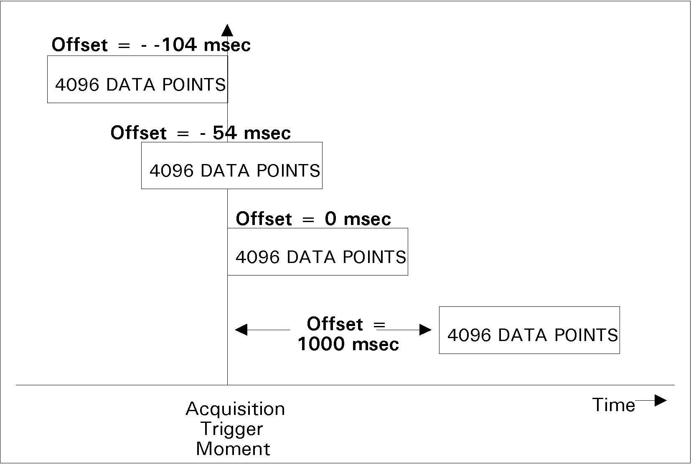

*Figure 33-1: Pre-event and Post-event Triggering*